TEAM CONTRACT
PROJECT:
  - TEAM MEMBER BACKGROUND AND CONTACT INFORMATION

Name | Phone | Preferred Medium of Contact

  - TEAM MEMBER AVAILABILITY FOR MEETINGS

Name | Monday | Tuesday | Wednesday | Thursday | Friday | Saturday/ Sunday

USING THE GRIP MODEL:
TO DEVELOP YOUR TEAM CONTRACT

Anything of strength and resilience has a solid foundation. To end a successful project as a strong, cohesive team requires starting it in a deliberate way.

We use the GRIP Model to bring the team together. This framework is referred back to throughout the project to ensure performance standards are upheld.
When problems occur during the project, whether it be with team member behavior, team chemistry, or under-performance, it is because vital time wasn’t invested upfront.
“Prevention is always better than a cure.”
As the adage goes: the first 15% of your preparation defines 85% of the result.

The GRIP Model is how to build effective, high-performing teams in any environment.

Goals. Set and commit to team goals that cascade to team members’ individual goals. This phase also covers developing team values, identity, behavioral expectations, and standards.
G
Roles. Expand team member roles beyond their technical or physical contribution. Identify each person’s strengths and match their team role to what comes naturally to them. (Their DISC Profile results are invaluable with this part.)
R
Interpersonal Relationships. Build self-awareness, understanding of others, and communication skills. Focus on team dynamics and establishing strong, effective relationships. (Again, DISC Profiles are relied on to put this into action.)
I
P

Processes and Procedures. Articulate clearly the behavioral standards and expectations. Cover everything and leave no questions about team rules.

GOALS
Whatever goal the team sets, there are consequences. Achieving top results demands commitment to certain actions. It is all about what you choose to do and not do, day in and day out.

While this step is called goals, it also covers the ‘how.’ How will the individuals on your team commit to the behaviors and individual goals needed to make your team goal a reality? These goals are reinforced by having a clear team identity and knowing what it stands for.

Considerable time is spent developing the team’s values and identity. From here, it is important to articulate the behaviors that will move you towards these goals (behaviors you want) and the behaviors you don’t want.
ROLES
Each individual’s role on your team goes far beyond just their technical expertise or strengths. Use DISC to not only explore
the technical roles you will each take on to complete the project, but to also identify the non-technical roles you can do.

INTERPERSONAL RELATIONSHIPS
To develop strong bonds between team members, invest time in building relationships. Not as a one-off activity (like creating this contract), but as a consistent element of your project. Managing conflict well within the
team relies on strong bonds. Using your DISC Profiles to understand your team dynamic turns differences into strengths, as each person is acknowledged and valued for their unique contribution.

Building this awareness and developing strategies is where the best team chemistry is achieved.
“Team building is not an event, it’s a process.”

PROCESSES AND PROCEDURES
By being crystal clear about expectations, everyone knows where they stand and what is required of them. Outline behavioral standards for travel, training, game plans, and injury management. Cover everything and assume nothing.

High-performing teams leave nothing to chance. Be proactive in how and what your team lives.

“It is about being the best for the team rather than the best on the team.”

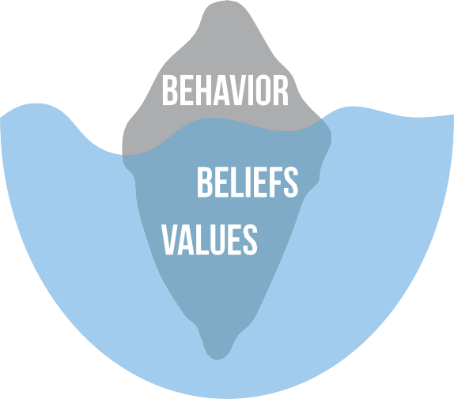
Goals
Whatever goal the team sets, there are consequences. Achieving top results demands commitment to certain actions. It is all about what you choose to do and not do, day in and day out.

While this step is called goals, it also covers the ‘how.’ How
will the individuals on your team commit to the behaviors and individual goals needed to make your team goal a reality? These goals are reinforced by having a clear team identity and knowing what it stands for. Considerable time is spent developing the team’s values and identity. From here, it is important to articulate the behaviors that will move you towards these goals (behaviors you want) and the behaviors you don’t want.

TEAM GOALS: WHAT GOALS DO WE HAVE FOR OUR TEAM?
Make them SMART – specific, measurable, achievable, relevant, and time-bound. Think about the things you can control. A grade is a worthy goal, but it’s not entirely within your control. It’s something you receive from the faculty at the end. Worse than the lack of control, when you get the grade, there’s nothing left that you can do to improve it. It’s over. Think about things that are completely within your control and things that you can do along the way (day-to-day or week-to-week) that make the grade you want more likely.

Goal 1 Goal 2 Goal 3

INDIVIDUAL TEAM MEMBER GOALS:
Do team members have any specific goals relating to the team experience? For example, does a teammate wish to use the team experience to improve his/her leadership skills, public speaking skills, become a better team player? As long as personal goals take a backseat to team goals, it’s perfectly acceptable to have them. Once you know each other’s personal goals, great teammates help each other achieve those goals in pursuit of the bigger team goals.

Name | Individual Goal

VALUES & BEHAVIORS
Identify three to five values that underpin your overall goal. Then identify the associated behaviors that will contribute to these values being lived in order for the goal to be achieved.

Values Associated Behaviors
Aligned | Working together, communicating, discussing ideas

ROLES

TECHNICAL AND NON-TECHNICAL

A role is each individual’s unique way of contributing to their team. Roles can be separated into technical and non-technical. This combination of both roles creates what we call the ‘behavioral scorecard’.

When a team member carries out their role, positive results will follow. The opposite can be said when they neglect their role. In this case, another team member will have to pick up their slack and potentially overextend themselves.
This can lead to possible performance issues and a potential breakdown in trust. Sometimes a team member may also overextend their role. This means willingly doing someone else’s job.
Again, the impact of this can be detrimental to the outcomes.
TEAM MEMBER SKILL INVENTORY:

TECHNICAL ROLES
A technical role is the mechanics of your job, like performing a task that contributes to the completion of your project.

NON-TECHNICAL ROLES
A non-technical role is the unique behavioral qualities an individual brings to their team. For example, being the most energetic person who brings enthusiasm to every team meeting, or being data-focused and analytical to identify areas of the project to work on for the benefit of the team. This could also be seen through an individual who drives cohesion in the team by including their fellow team members in social events, or takes an interest
in their lives beyond the project or class.
“Know your job. Do your job.”

Discuss team member skills/strengths and challenges/development areas. Refer to your DISC Profiles to support this. Examples of technical skills…document design, analytical skills, public speaking, project management. Examples of non-technical skills...decision making, leadership, attention to detail, goal setting, etc.

Name | Technical Skill | Non- Technical Skill | Opportunities for Development

TEAM ROLE ALLOCATION
Below are more in-depth team roles descriptions, and the likely DISC Profile best suited to the role. In total, there are nine ‘accepted’ team roles which have a likely correspondence to the variety of DISC Profiles. Use your team’s DISC Profiles to assist in the allocation of these roles in the last column to align with their preferred behavioral styles. For this exercise you can place multiple group members in the same role.

Summary | Roles | Description | DISC  Profile | Team Member Name
 | Implementer | Well-organized and predictable. Takes basic ideas and makes them work in practice. Can be slow. | Cd
Doing and Acting | Shaper | Lots of energy and action, challenging others to move forward. Can be insensitive. | Di
Doing and Acting | Completer/ Finisher | Reliably sees things through to the end, ironing out the wrinkles and ensuring everything works well. Can worry too much and not trust others. | CS
Thinking and Problem- Solving | Plant | Solves difficult problems with original and creative ideas. Can be a poor communicator and may ignore the details. | D
Thinking and Problem- Solving | Monitor/ Evaluator | Sees the big picture. Thinks carefully and accurately about things. May lack energy or ability to inspire others. | Dc
Thinking and Problem- Solving | Specialist | Has expert knowledge/skills in key areas and will solve many problems here. Can be disinterested in all other areas. | C
Thinking and Problem- Solving | Coordinator | Respected leader who helps everyone focus on their task. Can be seen as excessively controlling. | D
People and Feelings | Team Worker | Cares for individuals and the team. Good listener and works to resolve social problems. Can have problems making difficult decisions. | S, Si
 | Resource/ Investigator | Explores new ideas and possibilities with energy and with others. Good networker. Can be too optimistic and lose energy after the initial flush. | I, Is
Circle any team roles that are not being fulfilled.

TEAM LEADERSHIP AND ROLES
Do we want to appoint a formal team leader? If so, how (and when) will we select our leader? What is expected of the leader? If not, will we adopt a shared leadership approach within our team? Responsibilities that a leader might accept include organizing meetings, setting agendas, coordinating integration of individual contributions, or serving as a liaison between the team and the faculty and peer mentors. Note: most teams are tempted to take a shared leadership approach. There’s nothing wrong with that, but those teams tend to make more silly mistakes – like forgetting to submit a team assignment on time.

INTERPERSONAL RELATIONSHIPS
In contrast, someone
who has a high level
of Steadiness, is
indirect and slower-
paced (x-axis); open
DISC is a tool used to assess people’s behavior. It helps develop more awareness of how people do what
they do and gives them options for doing something different and better. Becoming a stronger team requires developing better relationships. DISC also helps us understand and value our group members.

For example,
someone with
a high level of
direct and faster-
Dominance, is
paced (x-axis);
guarded and goal-
focused (y-axis).

and relationship-
orientated (y-axis).

!

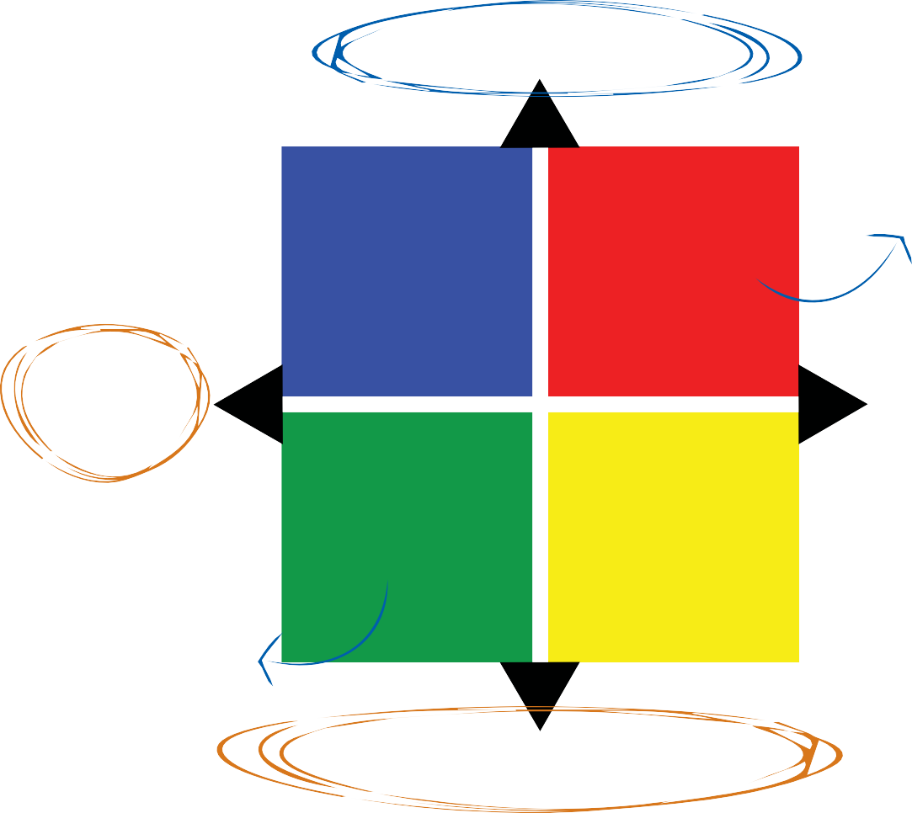
Conflict can occur with people of different DISC styles due to their opposing priorities (the y-axis, task/goal vs relationship/people focus) and/or their pace (x-axis, slower vs faster).
Guarded, Task/Goal-focused
Conscientious
Prepared Follows Rules Process Driven
Dominance Direct Decisive Results Focus
Indirect,
Slower-
paced
Direct,
Faster-
paced
Steadiness Influence
Patient Extroverted
Loyal Talkative
Team Focus Brings Energy
Open, Relationship/People-orientated

INSERT YOUR TEAM DYNAMIC WORKSHEET HERE.

Team Dynamic Worksheet

Introduction to the Team Dynamic Report
This Team Dynamic Report assists you to better understand and develop how well your team functions and performs. It provides an overview of the combination of different behavioral styles within your team or group, and has been created by using each person's DISC Profile results. Just as individuals have their own unique behavioral style, so too does a team.

WHAT IS A TEAM DYNAMIC AND TEAM CULTURE?

Culture is defined simply as the 'accepted and preferred behaviors within our team'. Culture is the way your team behaves, resulting in effective and productive outcomes, or ineffective and unproductive outcomes. Culture is ultimately a function of your mix of different DISC styles, and we call this your team dynamic. All teams have a specific team dynamic (and associated culture) which will be more appealing to some behavioral styles than others. Understanding how the team dynamic impacts the different behavioral styles enables the leader or manager to be more strategic about creating the 'right' type of culture for the goals the team is aiming to achieve.

WHAT IMPACTS TEAM CULTURE?

The team's culture is more than just the average of the different DISC styles within the team. The following are some of the factors which significantly impact the team culture:
- The behavioral style of the manager or leader;
- The 'extreme' behavioral styles within the team;
- The goals the team wants to achieve;
- The values (what is most important) and standards of the team; and
- The team's previous culture and history.

Understanding the above factors helps the leader(s) to make changes to the team dynamic and subsequent culture if it is not creating the desired results.

Within this report, we refer to your Adapted Style Dynamic and Natural Style Dynamic patterns. This is based on collective results of the individual DISC Profiles. As a reminder:
- Adapted Style: This is the self-perception of the way people believe they behave in their current work environment.

- Natural Style: This is someone's most preferred behaviors or their instinctive behaviors. This is how they act when they feel comfortable in an environment and feel that they do not need to make any changes to their behavior. It also predicts how they respond in stressful situations.
The team dynamic results contained within this report do rely on interpretation, so please discuss these results with your consultant. For an individual's results, please refer to their personalized DISC Profile report.

NATURAL Team Dynamic Results
NATURAL STYLES WITHIN THE FOUR QUADRANT DISC MODEL

Fill out the below graph with each team member's primary Natural DISC style within the four quadrant DISC model as taken from your Natural Style graph in your individual DISC Profile Report, include the primary and secondary styles.

Once you have added all group members into their primary quadrant below, calculate the percentages of your team that makes up each style. (E.g., if you have six group members, and one person is naturally highest in the Dominance 'D' style, divide 1 by 6 to get your team percentage of the 'D' style.)

Discuss how your team dynamic compares to the Norm Group percentage in each quadrant. (The Norm Group is the average of a normal, diverse population of people.)

OPEN
People-Oriented
GUARDED
Task-Oriented
DIRECT
Faster-Paced
INDIRECT
Slower-Paced

C as their Primary Style  ___% of your team  12% of the Norm Group | D as their Primary Style  ___% of your team  9% of the Norm Group
S as their Primary Style  ___% of your team  52% of the Norm Group | I as their Primary Style  ___% of your team  27% of the Norm Group

NATURAL Team Dynamic Discussion

Answer the following questions based on your Natural Team results on the previous page.

What are the likely consequences of any over or under-representations of a DISC style(s) on the team roles required for team performance, standards, and accountability?

Refer to the section in your individual DISC Profile reports titled ‘Tension Among the DISC Styles.’ Consider how different people within the team work well together, or where they could have conflict.

© Copyright Athlete Assessments (www.athleteassessments.com). All rights reserved.

Team Dynamic Report for Teams Trial Account 2021 I July 13, 2021

ADAPTED Team Dynamic Results
ADAPTED STYLES WITHIN THE FOUR QUADRANT DISC MODEL

Now, fill out the below graph with each team member's primary Adapted DISC style within the four quadrant DISC model as taken from your Adapted Style graph in your individual DISC Profile Report, include the primary and secondary styles.

Once you have added all group members into their primary quadrant below, calculate the percentages of your team that makes up each style. (E.g., if you have six group members, and one person is naturally highest in the Dominance 'D' style, divide 1 by 6 to get your team percentage of the 'D' style.)

OPEN
People-Oriented
GUARDED
Task-Oriented
DIRECT
Faster-Paced
INDIRECT
Slower-Paced

C as their Primary Style  ___% of your team  32% of the Norm Group | D as their Primary Style  ___% of your team  9% of the Norm Group
S as their Primary Style  ___% of your team  26% of the Norm Group | I as their Primary Style  ___% of your team  33% of the Norm Group

© Copyright Team8 & Athlete Assessments. All rights reserved.

ADAPTED Team Dynamic Discussion

Answer the following questions based on your Adapted Team results on the previous page.

What is likely to be driving these adaptations?

What are the likely impacts of these adaptations?

PROCESSES

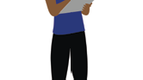

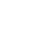


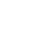
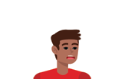

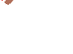
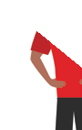
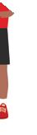
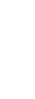
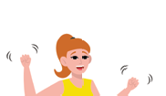
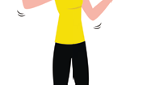
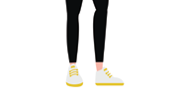




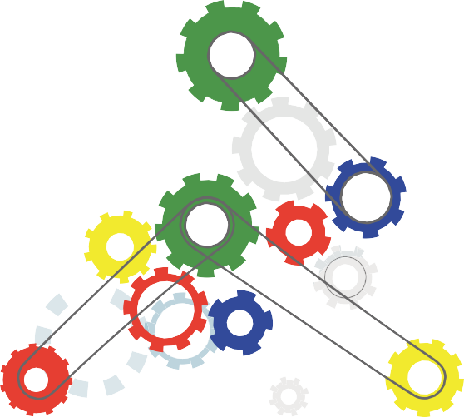

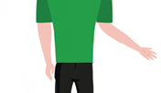
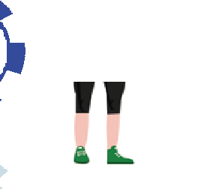

(Policies and Procedures)
Every high-performing team requires effective systems and processes.

Processes include, but aren’t limited to, meeting schedules, communication systems, project timelines, decision making, etc.

Each team member needs to adhere to the systems and processes. Sometimes processes need to be challenged to make them better.

MEETING GUIDELINES
Will we have regular meetings? How/where will we meet? Will we have meeting agendas? Will we take (and distribute) notes? If so who will take notes? Will there be a meeting facilitator (One person? Rotate among team members?) Are members allowed to call “time out” if a meeting is going off track, chatting rather than working, if the team seems to be “stuck” and not moving forward to accomplish what it had originally planned to?

COMMUNICATION
How will we communicate? Blackboard? Email? Discussion board? Phone? Text?

DECISION-MAKING
What decision-making process will we use (consensus, majority vote, etc.)? Are there certain decisions that must be agreed to by all members? Remember what Kathryn in The Five Dysfunctions of a Team says about consensus…

MONITORING PROGRESS
How will we monitor our progress to ensure we stay on schedule? Will we set formal dates/deadlines for milestones and important deliverables?

CONFLICT
If we run into a conflict, what process will we use to resolve it? What happens if we find ourselves falling into dysfunctional (unhealthy) conflict? Remember that the optimal level of conflict in a team is NOT zero. Healthy conflict is conflict that focuses on the quality of your work product. Unhealthy conflict is personal. Distinguish between the two.

PLANNING
Will we set time aside before we tackle a task to make specific plan (what is to be accomplished, who is responsible for what, what are deadlines/deliverable dates)?

HELPING BEHAVIORS
If a team member takes ownership of something but realizes they need help, is the team willing to pitch in to help? What process should team members use to ask for help? What are (un)acceptable reasons to ask for help?

SOCIAL LOAFING
What will we do if a teammate is not pulling his/her weight? Ignore the problem? Confront the person? Recognize the issue on peer evaluation? Other? What process will we use to address a social loafer?

TEAM COMMITMENTS

CONTRIBUTIONS
Expectation regarding team member contributions. Equal contributions? Team members to contribute to only to the areas they are assigned or have expertise in?

WORK QUALITY
What expectations do we have for the quality of work that is delivered by team members? How do we handle deliverables that do not meet team expectations with regard to content, quality, etc. Make sure to define what you mean by quality. If it’s ambiguous, different people can interpret it differently and that can lead to dysfunctional conflict after the fact.

MEETING ATTENDANCE
When is it okay to miss a meeting? Should teammates be notified if a member cannot attend (if so, when, and how)?
How will we ensure teammates are kept up to date after a missed meeting? How will we handle making decisions if a member is missing (Are decisions made only by attending members? Do we cycle back to the missing member before finalizing?)

PARTICIPATION
How can we encourage team members to participate and engage?

LATENESS
What constitutes a “late” deliverable”? (Are late deliverables acceptable? How do we deal with late deliverables?) Consider here deliverables that are internal to the team.

BEHAVIORS
Are there behaviors we expect from our teammates? Behaviors that are unacceptable? How do we plan to handle it if a team member displays unacceptable behaviors? The better you define them here, the less likely you are to face dysfunctional conflict later. Again, ambiguity now can feed feelings of unfairness or persecution later.

REWARDS
How will we reward team members’ outstanding contributions? (Publicly recognize outstanding work? Recognize performance on peer evaluation?)

OTHER COMMITMENTS
Anything else your team would like to add?

TEAM AGREEMENT

TEAM MEMBER NAME SIGNATURE

TEAM MEMBER NAME SIGNATURE

TEAM MEMBER NAME SIGNATURE

TEAM MEMBER NAME SIGNATURE

TEAM MEMBER NAME SIGNATURE

TEAM MEMBER NAME SIGNATURE

Tensions Among the DISC Styles

